**Advanced Machine and Deep Learning**

**Name : Shilpa Dinesh Singh**

**Roll No : 545**

**Class : Msc.Cs. Part 1**

**Practical No 1**

**Title : Implemented Simple Linear Regression**

import numpy as np

import matplotlib.pyplot as plt

import pandas as pd

dataset=pd.read_csv("/content/Salary_Data.csv")

x=dataset.iloc[:, :-1].values

y=dataset.iloc[:, -1].values

print(x)

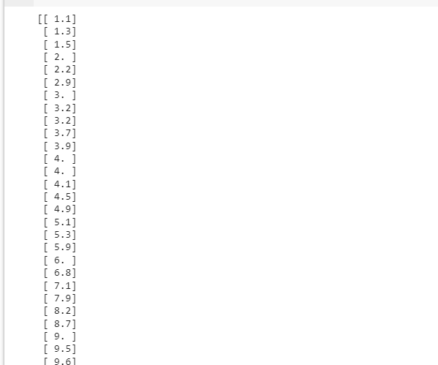

print(y)

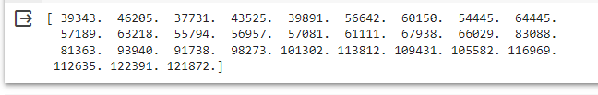

from sklearn.model_selection import train_test_split

x_train, x_test, y_train, y_test = train_test_split(x,y, test_size=1/3, random_state=0)

print(x_train)

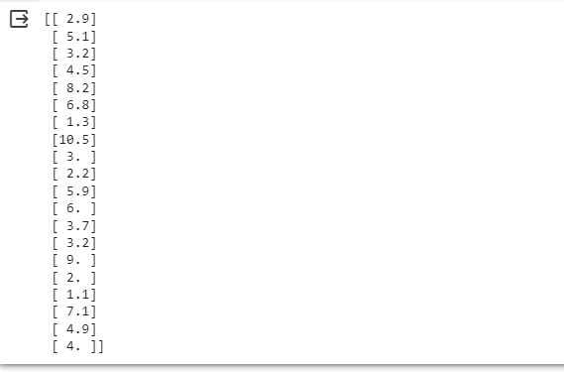

print(y_train)

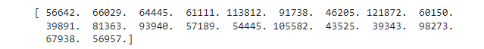

print(x_test)

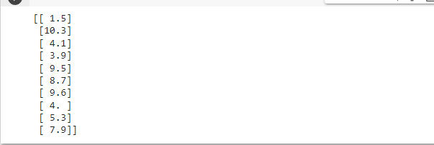

print(y_test)



from sklearn.linear_model import LinearRegression

regressor = LinearRegression()

regressor.fit(x_train, y_train)

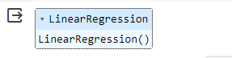

y_pred = regressor.predict(x_test)

plt.scatter(x_train, y_train,color='red')

plt.plot(x_train,regressor.predict(x_train),color='blue')

plt.title('Salary vs Experience (Training set)')

plt.xlabel ('Year of Experiene')

plt.ylabel ('Salary')

plt.show()

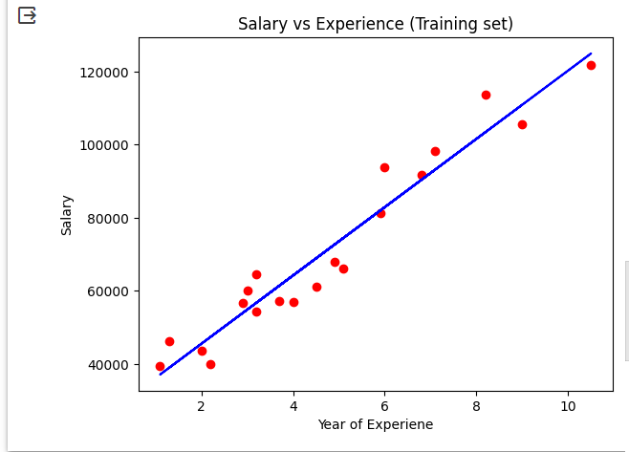

plt.scatter(x_test, y_test,color='red')

plt.plot(x_test,regressor.predict(x_test),color='blue')

plt.title('Salary vs Experience (Testing set)')

plt.xlabel ('Year of Experiene')

plt.ylabel ('Salary')

plt.show()

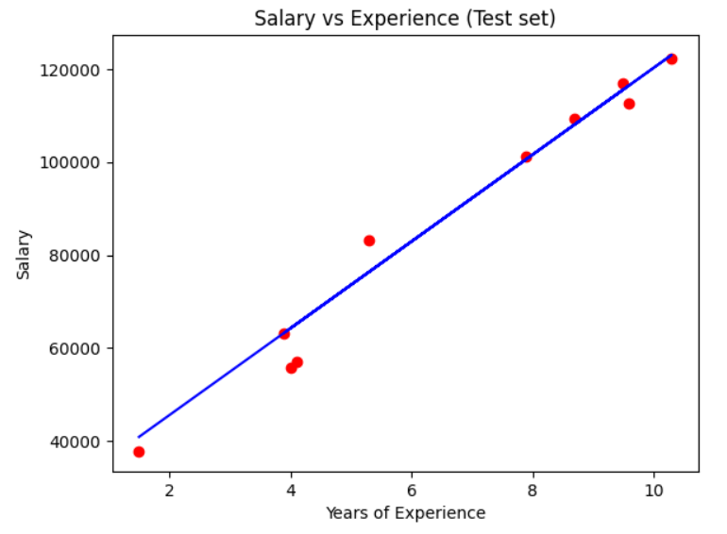

**Practical No 2**

**Title : Implement Multiple Linear Regression**

import numpy as np

import matplotlib.pyplot as plt

import pandas as pd

dataset = pd.read_csv("50_Startups.csv")

x=dataset.iloc[:, :-1].values

y=dataset.iloc[:, -1].values

print(x)

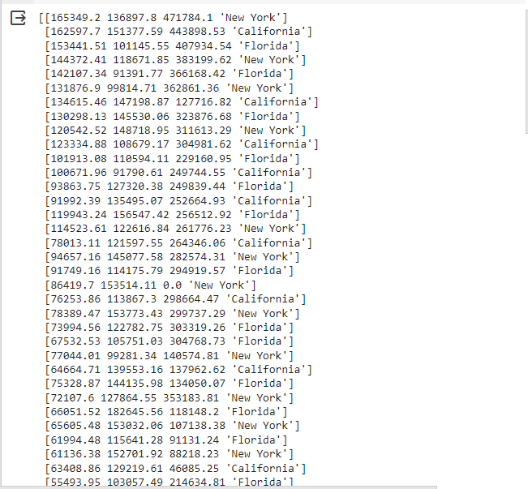

print(y)

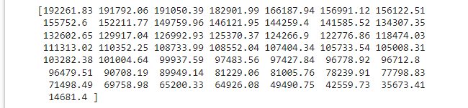

from sklearn.compose import ColumnTransformer

from sklearn.preprocessing import OneHotEncoder

ct = ColumnTransformer(transformers=[('encoded',OneHotEncoder(), [3])],remainder='passthrough')

x=np.array(ct.fit_transform(x))

from sklearn.model_selection import train_test_split

x_train, x_test, y_train, y_test = train_test_split(x,y, test_size=1/3, random_state=0)

print(x_train)

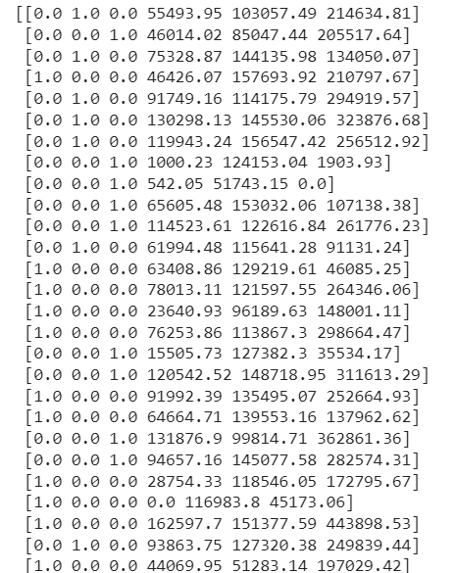

print (x_test)

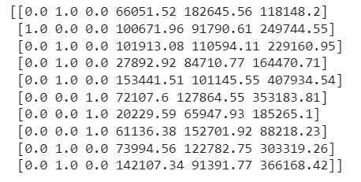

print(y_test)



print(Y_train)

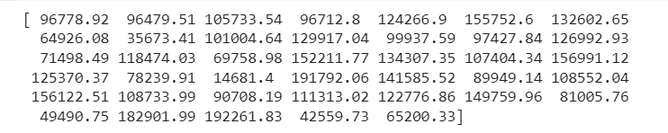

from sklearn.linear_model import LinearRegression

regressor=LinearRegression()

regressor.fit(x_train,y_train)

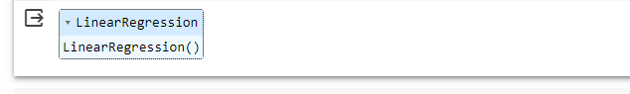

y_pred = regressor.predict(x_test)

np.set_printoptions(precision=2)

print(np.concatenate((y_pred.reshape(len(y_pred),1), y_test.reshape(len(y_test),1)),1 ))

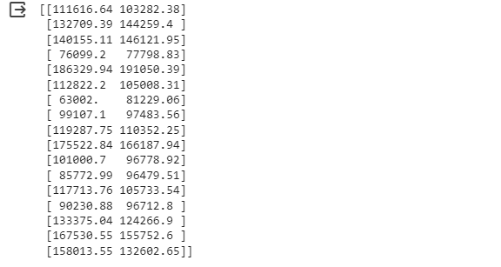

**Practical No 3**

**Title : Implement Logistic Regression For Classification On Iris Dataset**

import pandas as pd

iris_data = pd.read_csv('/content/Iris .csv')

#print(iris_data)

#iris_data.sample(5)

iris_data.head()

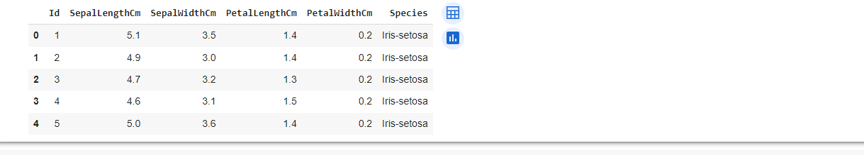

iris_data.info()

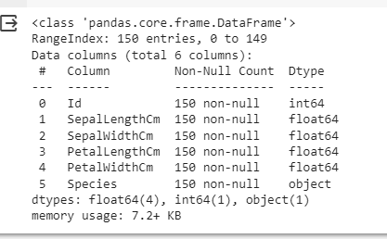

# Iris-setosa = 0 , Iris-versicolor = 1, Iris-virginica = 2

from sklearn.preprocessing import LabelEncoder

encoder = LabelEncoder()

iris_data['Species'] = encoder.fit_transform(iris_data['Species'])

iris_data.head(150)

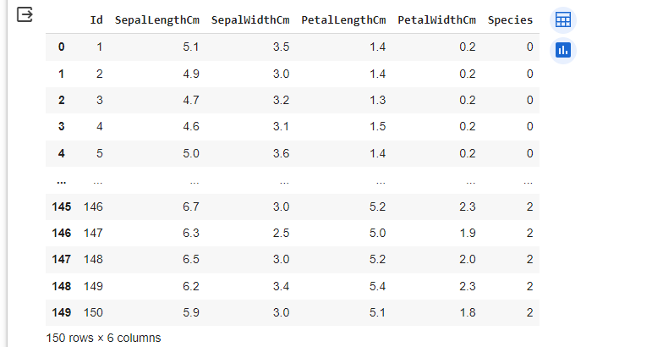

import matplotlib.pyplot as plt

plt.pie(iris_data['Species'].value_counts(),labels=['Setosa','Versicolor','Virginica'],autopct='%0.2f')

plt.show()

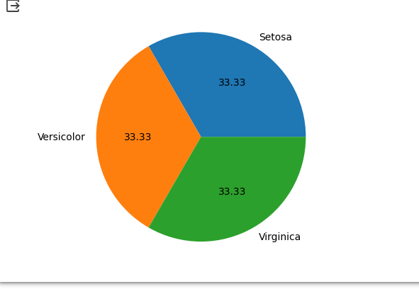

x = iris_data.drop('Species',axis=1)

y = iris_data['Species']

print(x)

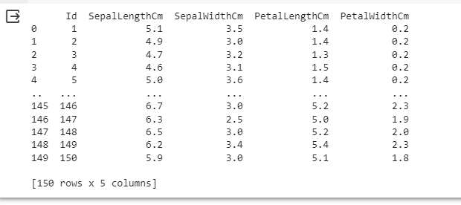

print(y)

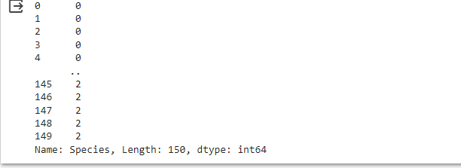

from sklearn.model_selection import train_test_split

x_train,x_test,y_train,y_test = train_test_split(x,y,test_size=0.2,random_state=2)

from sklearn.linear_model import LogisticRegression

model = LogisticRegression(max_iter = 1000)

model.fit(x_train,y_train)

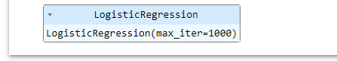

pred_train = model.predict(x_train)

from sklearn.metrics import confusion_matrix,accuracy_score

accuracy_score(y_train,pred_train)



pred_test = model.predict(x_test)

accuracy_score(y_test,pred_test)



confusion_matrix(y_test,pred_test)

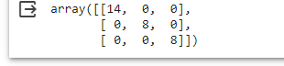

**Practical No 4**

**Title : Implement Social Media Ads Classification Using Support Vector Machine**

import numpy as np

import matplotlib.pyplot as plt

import pandas as pd

dataset = pd.read_csv('Social_Network_Ads.csv')

X = dataset.iloc[:, :-1].values

Y = dataset.iloc[:, -1].values

from sklearn.model_selection import train_test_split

X_train, X_test, Y_train, Y_test = train_test_split(X, Y, test_size =0.25, random_state = 0)

print(X_train)

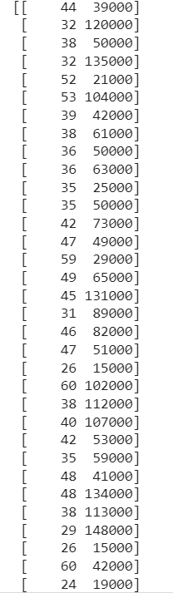

print(X_test)

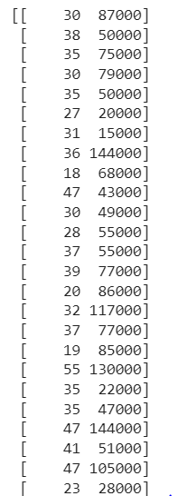

print(Y_train)

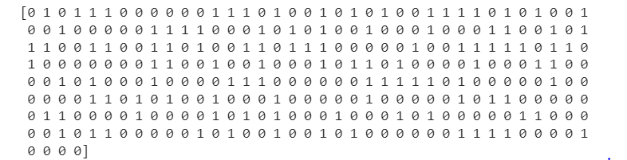

print(Y_test)

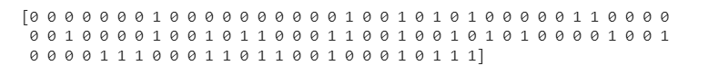

from sklearn.preprocessing import StandardScaler

sc = StandardScaler()

X_train = sc.fit_transform(X_train)

X_test = sc.transform(X_test)

print (X_train)

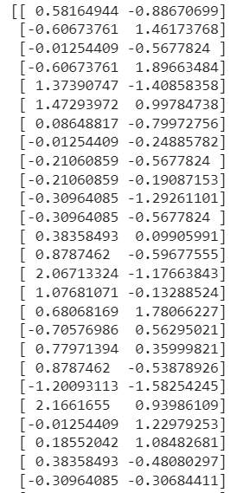

print(X_test)

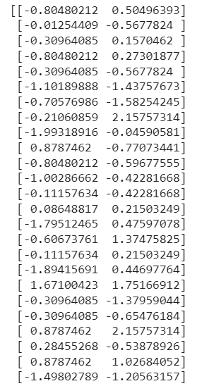

from sklearn.svm import SVC

classifier = SVC(kernel = 'linear', random_state = 0)

classifier.fit(X_train, Y_train)

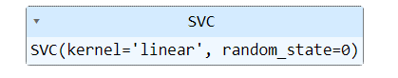

print(classifier.predict(sc.transform([[30,87000]])))



Y_pred = classifier.predict(X_test)

print(np.concatenate((Y_pred.reshape(len(Y_pred),1),Y_test.reshape(len(Y_test),1)),1))

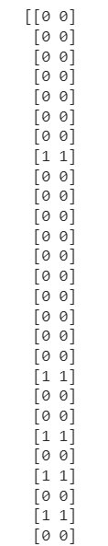

from sklearn.metrics import confusion_matrix, accuracy_score

cm = confusion_matrix(Y_test, Y_pred)

print(cm)

accuracy_score(Y_test, Y_pred)

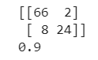

**Practical No 5**

**Title : Implement Social Media Ads Classification Using KNN**

import numpy as np

import matplotlib.pyplot as plt

import pandas as pd

dataset = pd.read_csv('Social_Network_Ads.csv')

X = dataset.iloc[:, :-1].values

Y = dataset.iloc[:, -1].values

from sklearn.model_selection import train_test_split

X_train, X_test, Y_train, Y_test = train_test_split(X,Y, test_size = 0.25, random_state = 0)

print(X_train)

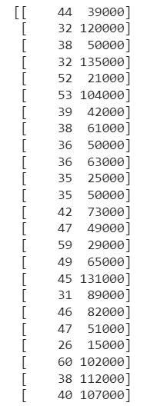

print(X_test)

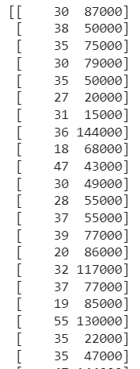

print(Y_train)

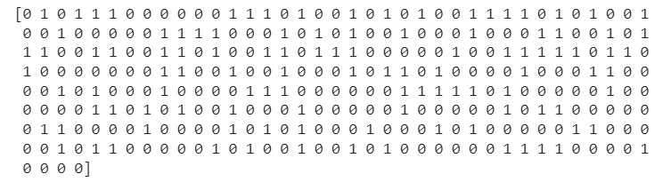

print(Y_test)

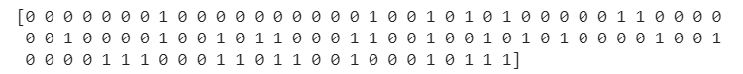

from sklearn.preprocessing import StandardScaler

sc = StandardScaler()

X_train = sc.fit_transform(X_train)

X_test = sc.transform (X_test)

print(X_train)

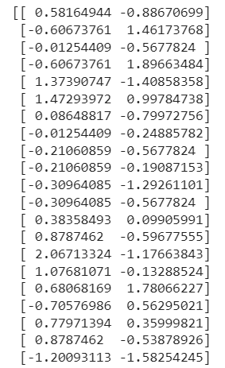

print(X_test)

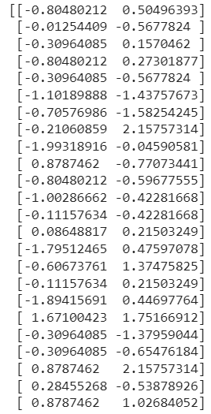

from sklearn.neighbors import KNeighborsClassifier

classifier = KNeighborsClassifier(n_neighbors = 5, metric = 'minkowski', p = 2)

classifier.fit(X_train, Y_train)

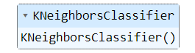

print(classifier.predict(sc.transform([[40,200000]])))



Y_pred = classifier.predict(X_test)

print(np.concatenate((Y_pred.reshape(len(Y_pred), 1), Y_test.reshape(len(Y_test), 1)), 1))

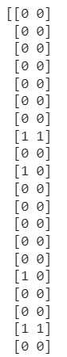

from sklearn.metrics import confusion_matrix, accuracy_score

cm = confusion_matrix(Y_test, Y_pred)

print(cm)

accuracy_score(Y_test, Y_pred)

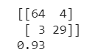

**Practical No 6**

**Title : Implement K–means Clustering**

import numpy as np

import matplotlib.pyplot as plt

import pandas as pd

dataset = pd.read_csv('/content/Mall_Customers.csv')

x = dataset.iloc[:, [3, 4]].values

print(x)

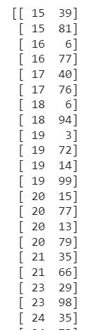

from sklearn.cluster import KMeans

wcss = []

for i in range(1, 11):

  kmeans = KMeans(n_clusters = i, init = 'k-means++', random_state = 42)

  kmeans.fit(x)

  wcss.append(kmeans.inertia_)

plt.plot(range(1, 11), wcss)

plt.title('The Elbow Method')

plt.xlabel('Number of clusters')

plt.ylabel('WCSS')

plt.show()

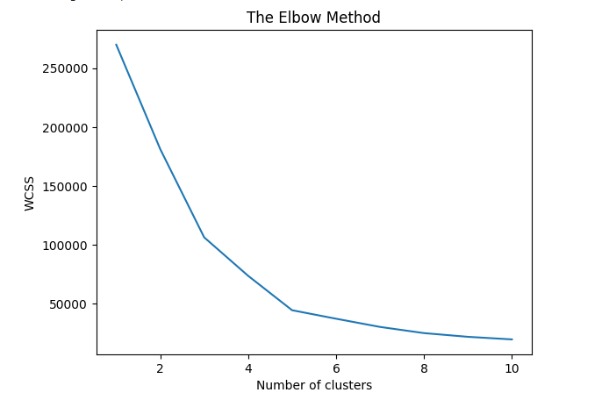

from sklearn.cluster import KMeans

kmeans = KMeans(n_clusters = 5, init = 'k-means++', random_state = 42)

y_kmeans = kmeans.fit_predict(x)

print(y_kmeans)

plt.scatter(x[y_kmeans == 0,0], x[y_kmeans == 0,1], s = 100, c= 'red', label = 'Cluster 1')

plt.scatter(x[y_kmeans == 1,0], x[y_kmeans == 1,1], s = 100, c= 'blue', label = 'Cluster 2')

plt.scatter(x[y_kmeans == 2,0], x[y_kmeans == 2,1], s = 100, c= 'green', label = 'Cluster 3')

plt.scatter(x[y_kmeans == 3,0], x[y_kmeans == 3,1], s = 100, c= 'cyan', label = 'Cluster 4')

plt.scatter(x[y_kmeans == 4,0], x[y_kmeans == 4,1], s = 100, c= 'magenta', label = 'Cluster 5')

plt.scatter(kmeans.cluster_centers_[:, 0], kmeans.cluster_centers_[:, 1], s = 300, c = 'yellow', label = 'Centroids')

plt.title('Clusters of customers')

plt.xlabel('Annual Income (k$)')

plt.ylabel('Spending Score (1-100)')

plt.legend()

plt.show()

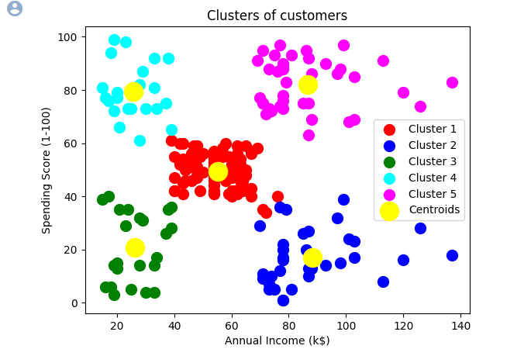

**Practical No 7**

**Title : Implement Hierarchical Clustering**

import numpy as np

import matplotlib.pyplot as plt

import pandas as pd

dataset = pd.read_csv('/content/Mall_Customers.csv')

x = dataset.iloc[:, [3, 4]].values

print(x)

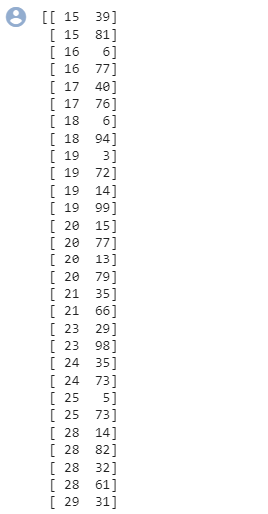

import scipy.cluster.hierarchy as sch

dendrogram = sch.dendrogram(sch.linkage(x, method = 'ward'))

plt.title('Dendogram')

plt.xlabel('Customers')

plt.ylabel('Eucliden distances')

plt.show()

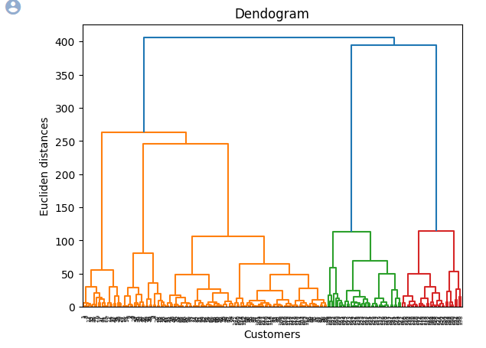

from sklearn.cluster import AgglomerativeClustering

hc = AgglomerativeClustering(n_clusters = 5, affinity = 'euclidean', linkage = 'ward')

y_hc = hc.fit_predict(x)

print(y_hc)

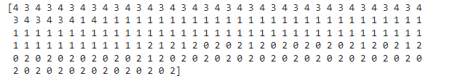

plt.scatter(x[y_hc == 0,0], x[y_hc == 0,1], s = 100, c= 'red', label = 'Cluster 1')

plt.scatter(x[y_hc == 1,0], x[y_hc == 1,1], s = 100, c= 'blue', label = 'Cluster 2')

plt.scatter(x[y_hc == 2,0], x[y_hc == 2,1], s = 100, c= 'green', label = 'Cluster 3')

plt.scatter(x[y_hc == 3,0], x[y_hc == 3,1], s = 100, c= 'cyan', label = 'Cluster 4')

plt.scatter(x[y_hc == 4,0], x[y_hc == 4,1], s = 100, c= 'magenta', label = 'Cluster 5')

plt.title('Clusters of customers')

plt.xlabel('Annual Income (k$)')

plt.ylabel('Spending Score (1-100)')

plt.legend()

plt.show()

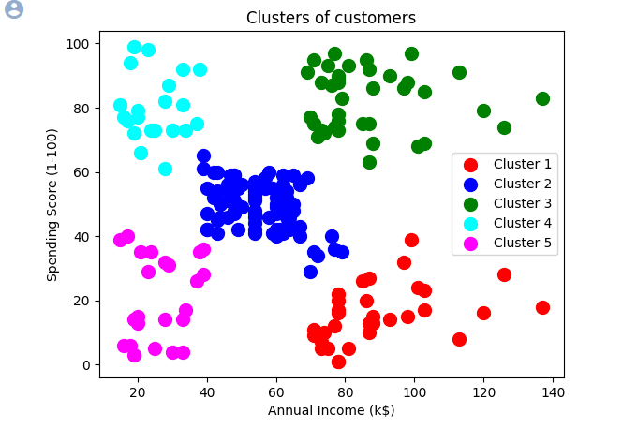

**Practical No 8**

**Title : Write A Program To Generate A Few Activation Function That Are Being Used In Neural Network**

#sigmoid function

import numpy as np

import matplotlib.pyplot as plt

import numpy as np

plt.style.use('seaborn')

plt.figure(figsize=(8,4))

def SigmoidBinary(t):

    return 1/(1+np.exp(-t))

t = np.linspace(-5, 5)

plt.plot(t, SigmoidBinary(t))

plt.title('Binary Sigmoid Activation Function')

plt.show()

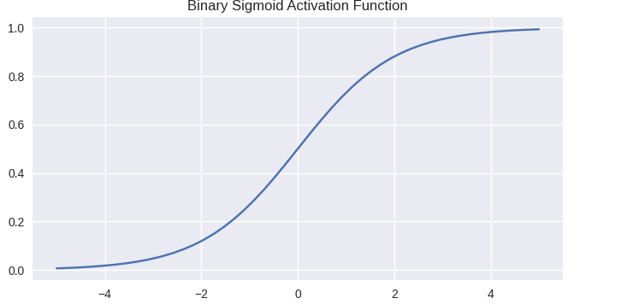

#Hyperbolic tangent function

plt.style.use('seaborn')

plt.figure(figsize=(8,4))

def HyperbolicTan(t):

    return np.tanh(t)

t = np.linspace(-5, 5)

plt.plot(t, HyperbolicTan(t))

plt.title('Hyperbolic Tan Activation Function')

plt.show()

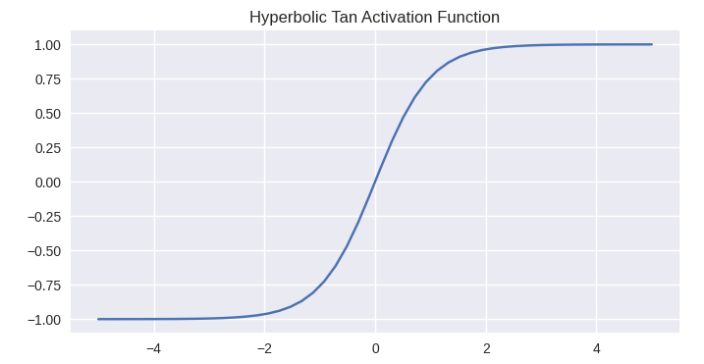

#Relu(Rectified linear unit)

plt.style.use('seaborn')

plt.figure(figsize=(8,4))

def RectifiedLinearUnit(t):

    lst=[]

    for i in t:

        if i>=0:

            lst.append(i)

        else:

            lst.append(0)

    return lst

arr = np.linspace(-5, 5)

plt.plot(arr, RectifiedLinearUnit(arr))

plt.title('Rectified Linear Unit Activation Function')

plt.show()

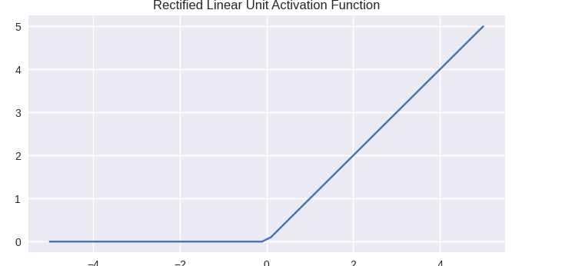

#Binary step function

plt.style.use('seaborn')

plt.figure(figsize=(8,4))

def binaryStep(x):

    lst=[]

    for i in t:

        if i>=0:

            lst.append(1)

        else:

            lst.append(0)

    return lst

x = np.linspace(-10, 10)

plt.plot(x, binaryStep(x))

plt.axis('tight')

plt.title('Activation Function :binaryStep')

plt.show()

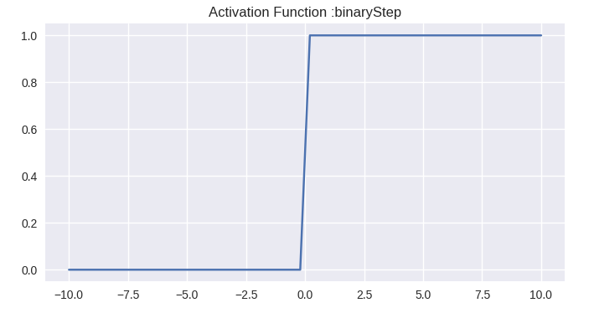

#linear activation function

def linear(x):

    ''' y = f(x) It returns the input as it is'''

    return x

x = np.linspace(-10, 10)

plt.plot(x, linear(x))

plt.axis('tight')

plt.title('Activation Function :Linear')

plt.show()

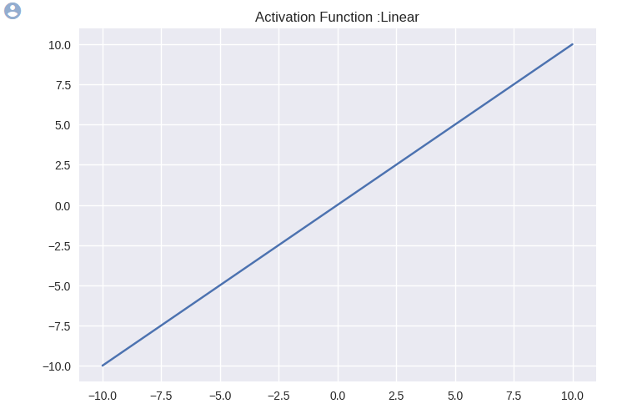

#softmax activation function

import numpy as np

import matplotlib.pyplot as plt

import numpy as np

plt.style.use('seaborn')

plt.figure(figsize=(8,4))

def softmax(t):

    return np.exp(t) / np.sum(np.exp(t))

t = np.linspace(-5, 5)

plt.plot(t, softmax(t))

plt.title('Softmax Activation Function')

plt.show()

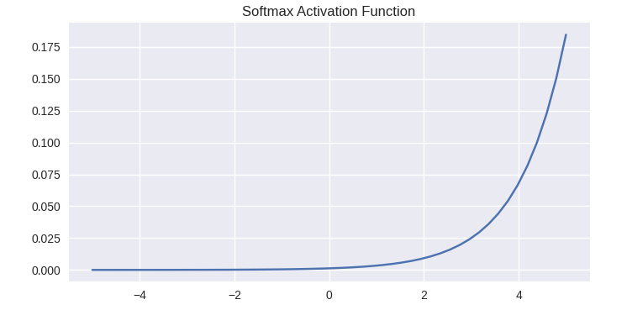

**Practical No 9**

**Title : Implement Tensor Operation(Add, Sub, Mul, Div & Less)**

import numpy as np

tensor_id = np.array([1.3, 1, 4.0, 23.99])

print(tensor_id)



print(tensor_id[0])



print(tensor_id[2])



**CREATE TWO DIMENSIONAL TENSOR**

import numpy as np

tensor_2d = np.array([(1, 2, 3, 4), (4, 5, 6, 7), (8, 9, 10, 11), (12, 13, 14, 15)]

print(tensor_2d)

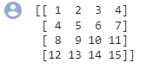

tensor_2d[3] [2]



**TENSOR HANDLING AND MANIPULATION**

import tensorflow as tf

import numpy as np

matrix1 = np.array([(2, 2, 2), (2, 2, 2), (2, 2, 2)], dtype = 'int32')

matrix2 = np.array([(1, 1, 1), (1, 1, 1), (1, 1, 1)], dtype = 'int32')

print(matrix1)

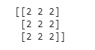

print(matrix2)

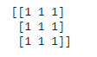

matrix1 = tf.constant(matrix1)

matrix2 = tf.constant(matrix2)

matrix_product = tf.matmul(matrix1, matrix2)

matrix_sum = tf.add(matrix1, matrix2)

matrix_sub = tf.subtract(matrix1, matrix2)

matrix_div = tf.divide(matrix1, matrix2)

matrix_3 = np.array([(2, 7, 2), (1, 4, 2), (9, 0, 2)], dtype = 'float32')

print(matrix_3)

print(matrix_product)

print(matrix_sum)

print(matrix_sub)

print(matrix_div)

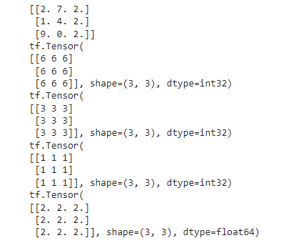

#importing the library

import tensorflow as tf

#initializing the input tensor

a = tf.constant([7, 8, 13, 11], dtype = tf.float64)

b = tf.constant([2, 13, 14, 5], dtype = tf.float64)

#printing the input tensor

print('a:', a)

print('b:', b)



res = tf.math.less(x = a, y = b)

print('Result:', res)



**Practical No 10**

**Title : Artificial Neural Network**

import numpy as np

import pandas as pd

import tensorflow as tf

tf.__version__



dataset = pd.read_csv('/content/Churn_Modelling.csv')

X = dataset.iloc[:, 3:-1].values

Y = dataset.iloc[:, -1].values

print(X)

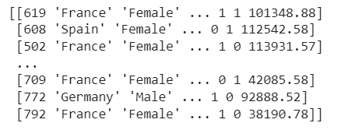

print(Y)



from sklearn.preprocessing import LabelEncoder

le = LabelEncoder()

X[:, 2] = le.fit_transform(X[:, 2])

print(X)

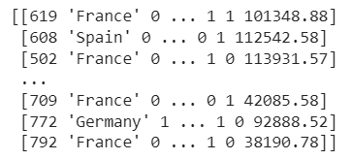

from sklearn.compose import ColumnTransformer

from sklearn.preprocessing import OneHotEncoder

ct = ColumnTransformer(transformers=[('encoder', OneHotEncoder(), [1])], remainder='passthrough')

X = np.array(ct.fit_transform(X))

print(X)

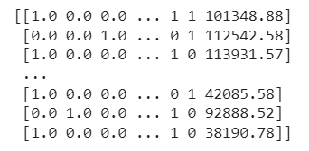

from sklearn.model_selection import train_test_split

X_train, X_test, Y_train, Y_test = train_test_split(X, Y, test_size = 0.2, random_state = 0)

from sklearn.preprocessing import StandardScaler

sc = StandardScaler()

X_train = sc.fit_transform(X_train)

X_test = sc.transform(X_test)

ann = tf.keras.models.Sequential()

ann.add(tf.keras.layers.Dense(units=6, activation='relu'))

ann.add(tf.keras.layers.Dense(units=6, activation='relu'))

ann.add(tf.keras.layers.Dense(units=1, activation='sigmoid'))

ann.compile(optimizer = 'adam', loss = 'binary_crossentropy', metrics = ['accuracy'])

ann.fit(X_train, Y_train, batch_size = 32, epochs = 100)

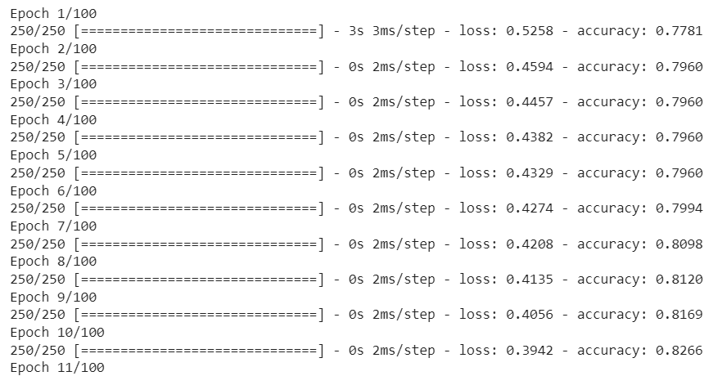

Y_pred = ann.predict(X_test)

Y_pred = (Y_pred > 0.5)

print(np.concatenate((Y_pred.reshape(len(Y_pred),1), Y_test.reshape(len(Y_test),1)),1))

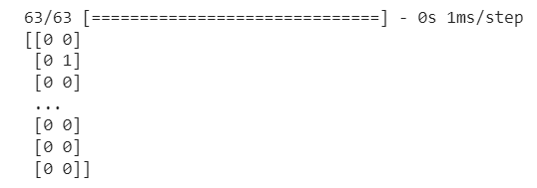

from sklearn.metrics import confusion_matrix, accuracy_score

cm = confusion_matrix(Y_test, Y_pred)

print(cm)

accuracy_score(Y_test, Y_pred)

